Steps

1. Install

In order to start the application run the executable “ShoppingCart.exe”

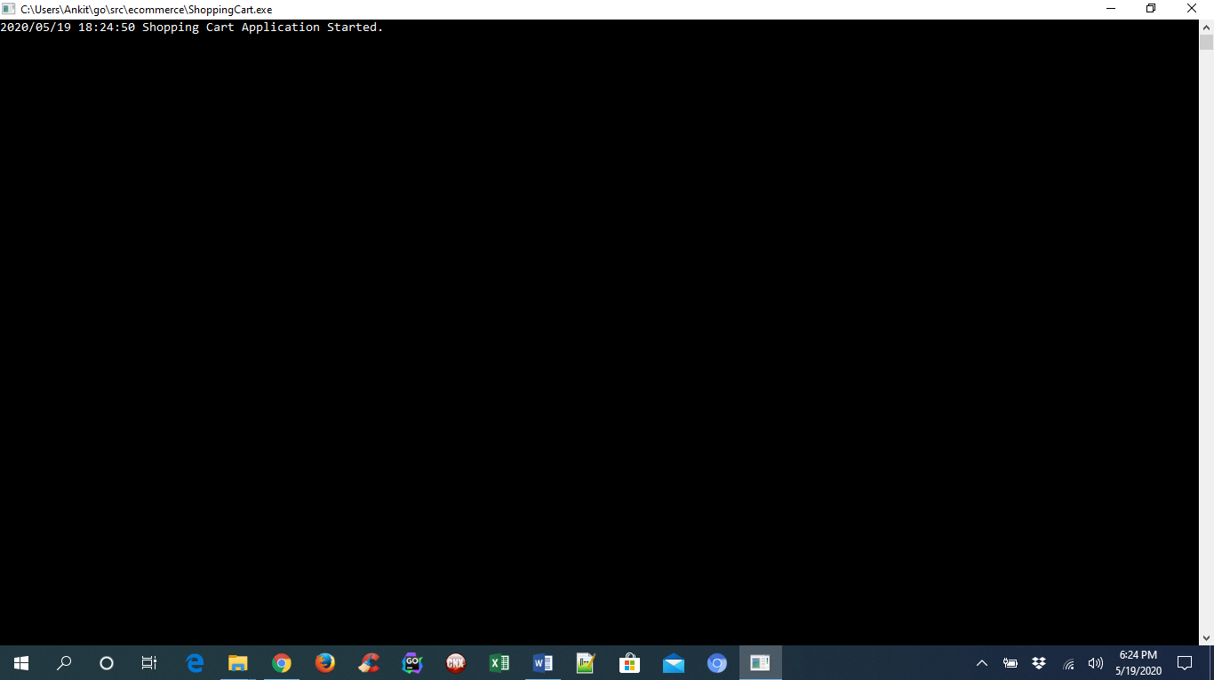

Alternately, you can run command “go build main.go” to generate the executable.

1. Login

Use the link to login to the application. <http://localhost:8000/>

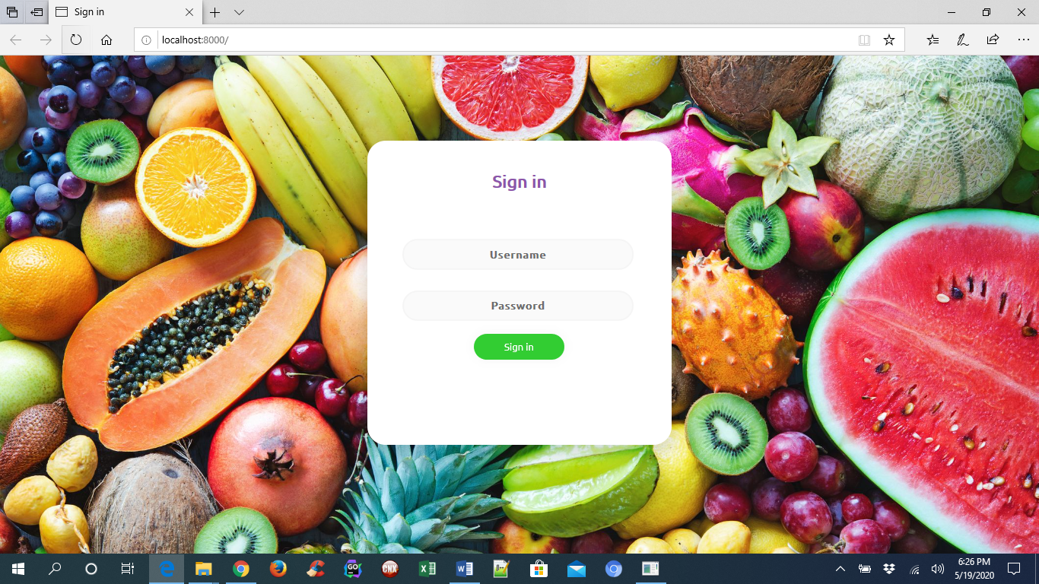

Login credentials:

UserID: admin

Password: admin

1. Shopping Page displayed

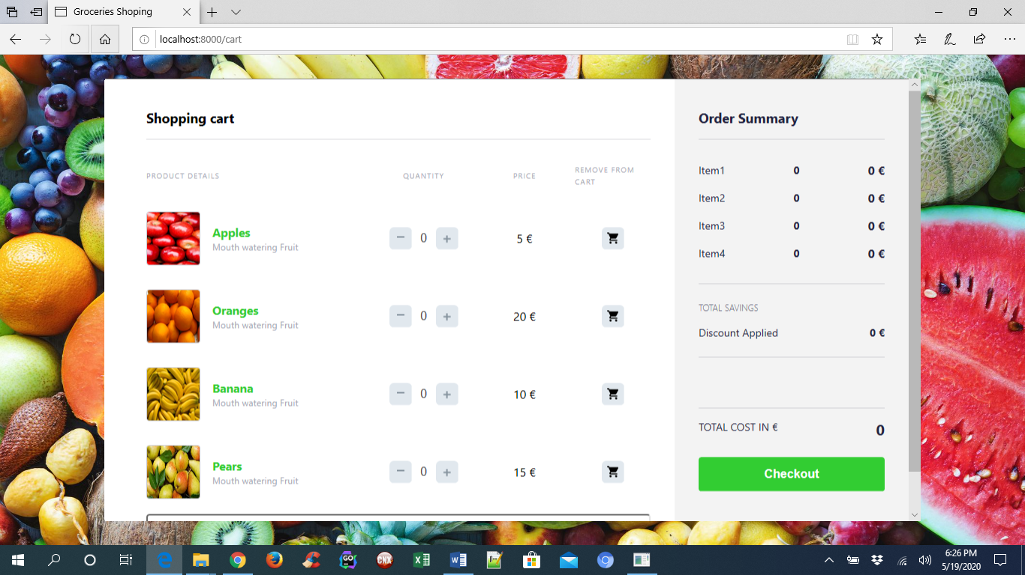

Items ordered:

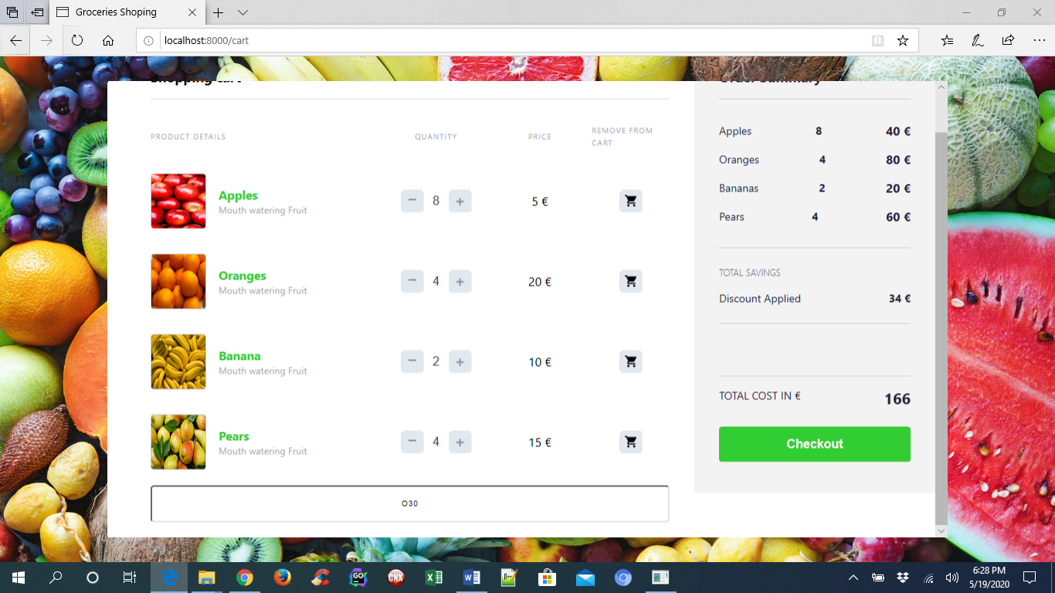

Note: The discount is applied. For oranges the promo code to get 30 % discount is “O30”.

1. Checkout loads payment page

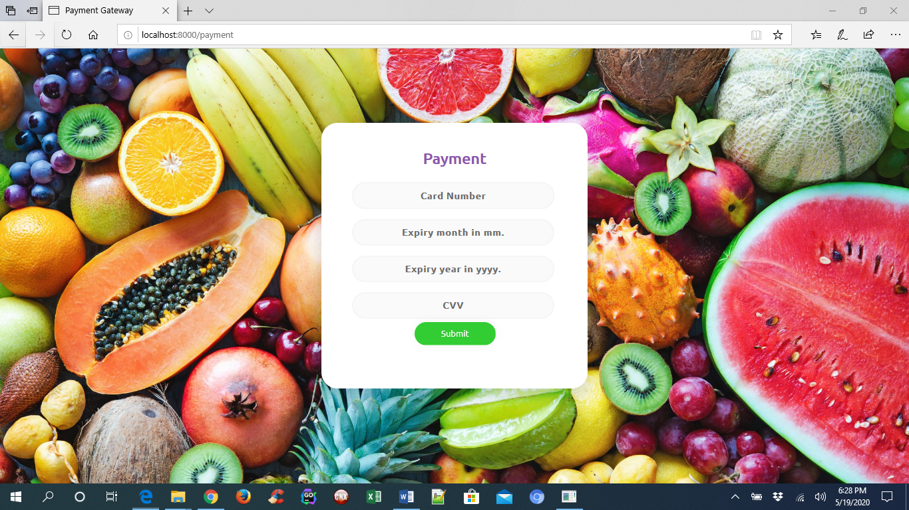

Payment Details for successful payment:

Card Number: 1234567812345678

Expiry: 06/2020

CVV: 987

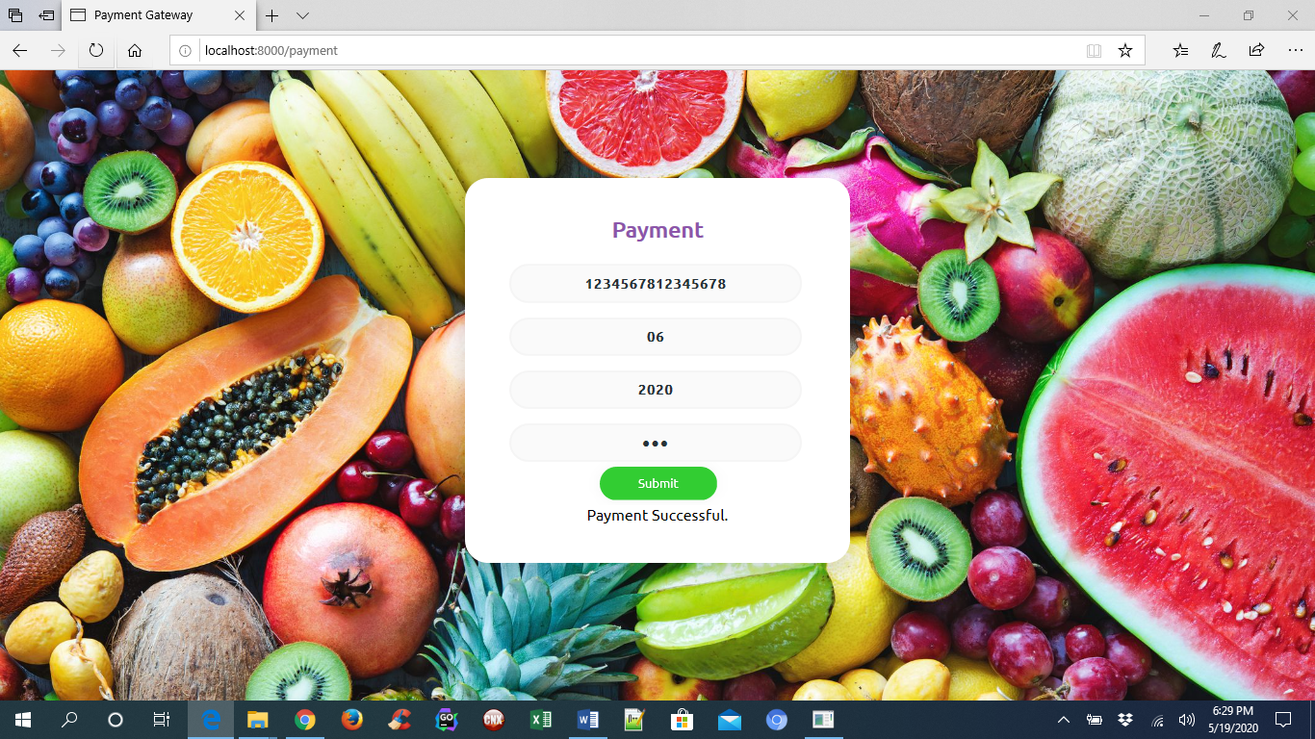

1. Logging in Console

